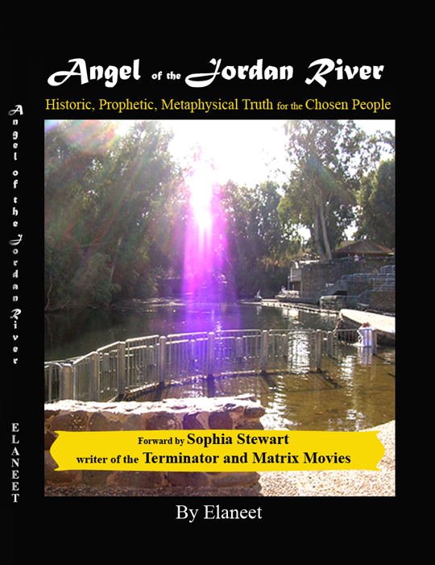

Thank you for your interest in Angel of the Jordan River. A book about Africans including those in the Diaspora. It teaches about the riddle that has eluded us as a people for over four thousand years and includes metaphysical modalities such as yoga, celestial science and natural living subjects common to African people. Most poignantly it answers the all important question; “Why does the creator allow so many horrific thing to happen to our people as a whole?”

To receive the answer to this and other questions I had to travel 7,000 miles to meet the force that guides and heals. They say all roads lead back to Jerusalem - now I know why.

The picture on the cover of this book was taken at the Jordan River in the Holy Land. I took it on my third visit to the river. My first experience in the river made me quiver upon entering the water. I had felt that way before but never as powerfully as I did that day looking up into the rays of the heavens. I could feel a power enlivening my atoms. Looking up I then saw light beams showering down upon me, filling every space of my being. I knew then that I had been spiritually altered.

The second time in the river the transformation was more external as my material world changed dramatically.

Stepping out of the river on my third visit I turned and clicked my camera. Not really expecting anything, I put the camera away for weeks. Then one day I decided to look at my pictures. Lo and behold! What I captured on that blessed day was the brilliance of the power that has fortified the Jordan River for thousands and thousands of years. This image is actually what I saw the first time in the water. This image is the Angel of the Jordan River.

Opening myself up to the realm of receiving such a blessing was a divine and holy journey. I have included an aspect of it for you in the following excerpt:

EXCERPT FROM
Angel of the Jordan River
By Elaneet
Pg 52-54

In our classes we were taught the most important lesson that a person can ever learn. It is the key to survival in this dimension and the root of success in all things…simply put...learning to “Let Go and Let God”. Letting go and Letting God is an innocent (almost childlike) profundity. It is a non acceptance of anything that is adverse or negative. Like the child who innately knows that they are safe in the arms of a loving mother, we too, have to know no fear. I learned that the only thing to fear is fear itself. Be afraid of being afraid and let God take control of your affairs. Don’t lean on your limited awareness. Pray and tell God what you want then Let it Go for fear is the absence of faith.

Our very essence is that of a creative being. We possess the ability to construct the things that we envision via the power of our subconscious mind. That mind doesn’t reason as our conscious mind does. Our subconscious mind just responds to the visions imprinted upon it by our thoughts. This imprint or impression follows us where ever we go for it is in our minds and we can never leave it behind. Where ever we are in the world. Where ever we run. No matter where we hide… there we will be. Our worlds are our creations. We are all self made it is just that the rich and successful are the ones who are wise enough to realize it.

It takes thought to consider fear and remember a fear thought left unchecked in our subconscious mind will become real. After all, your subconscious mind does what it is designed to do – create! When the image of an unchecked thought comes to life, an undeveloped soul would say “I knew it”. A master will avoid any such scenario by identifying the thought and deleting it by saying “I cancel that thought”. A master would go on, for example, to use the energy associated perhaps with a fear thought by replacing it with a desire. You can do the same. In essence when you think a fear thought, catch yourself and replace the thought with a positive thought and send it out on the wavelength of the energy that you felt. This particular lesson came to me via a dream:

I went to respond to the doorbell only to be met by a scary looking “thing”. I ran away from the door in utter fear. Then a force within me told me to turn around and go back to the door. I had to go back and confront my fear. I was mortified. I thought to myself that it was so immensely terrifying that I was not physically powerful enough to tackle such a thing. But the force in me insisted that I confront it, and so I did. I collected myself to run up to it. Then, with the same fierce intensity that it had come to me with, I looked it dead into its “intimidating” eyes standing my ground. I forgot my fear and held firm to my spiritual mandate. Very unexpectedly, it sublimated and yielded to my strength then went away.

I loved the yoga classes. Each one seemed to unfold a new and different petal of my rose. Each exposed a hidden beauty that was lying dormant beneath layer after layer of thoughts, fears, and impressions. Some were real - some unreal, but none were interminable.

